SALIENT Food Trials Newsletter
Issue 2 | March 2025

Welcome to the second SALIENT Newsletter
We aim to upload this newsletter two or three times a year, to give updates about the SALIENT studies that are taking place.
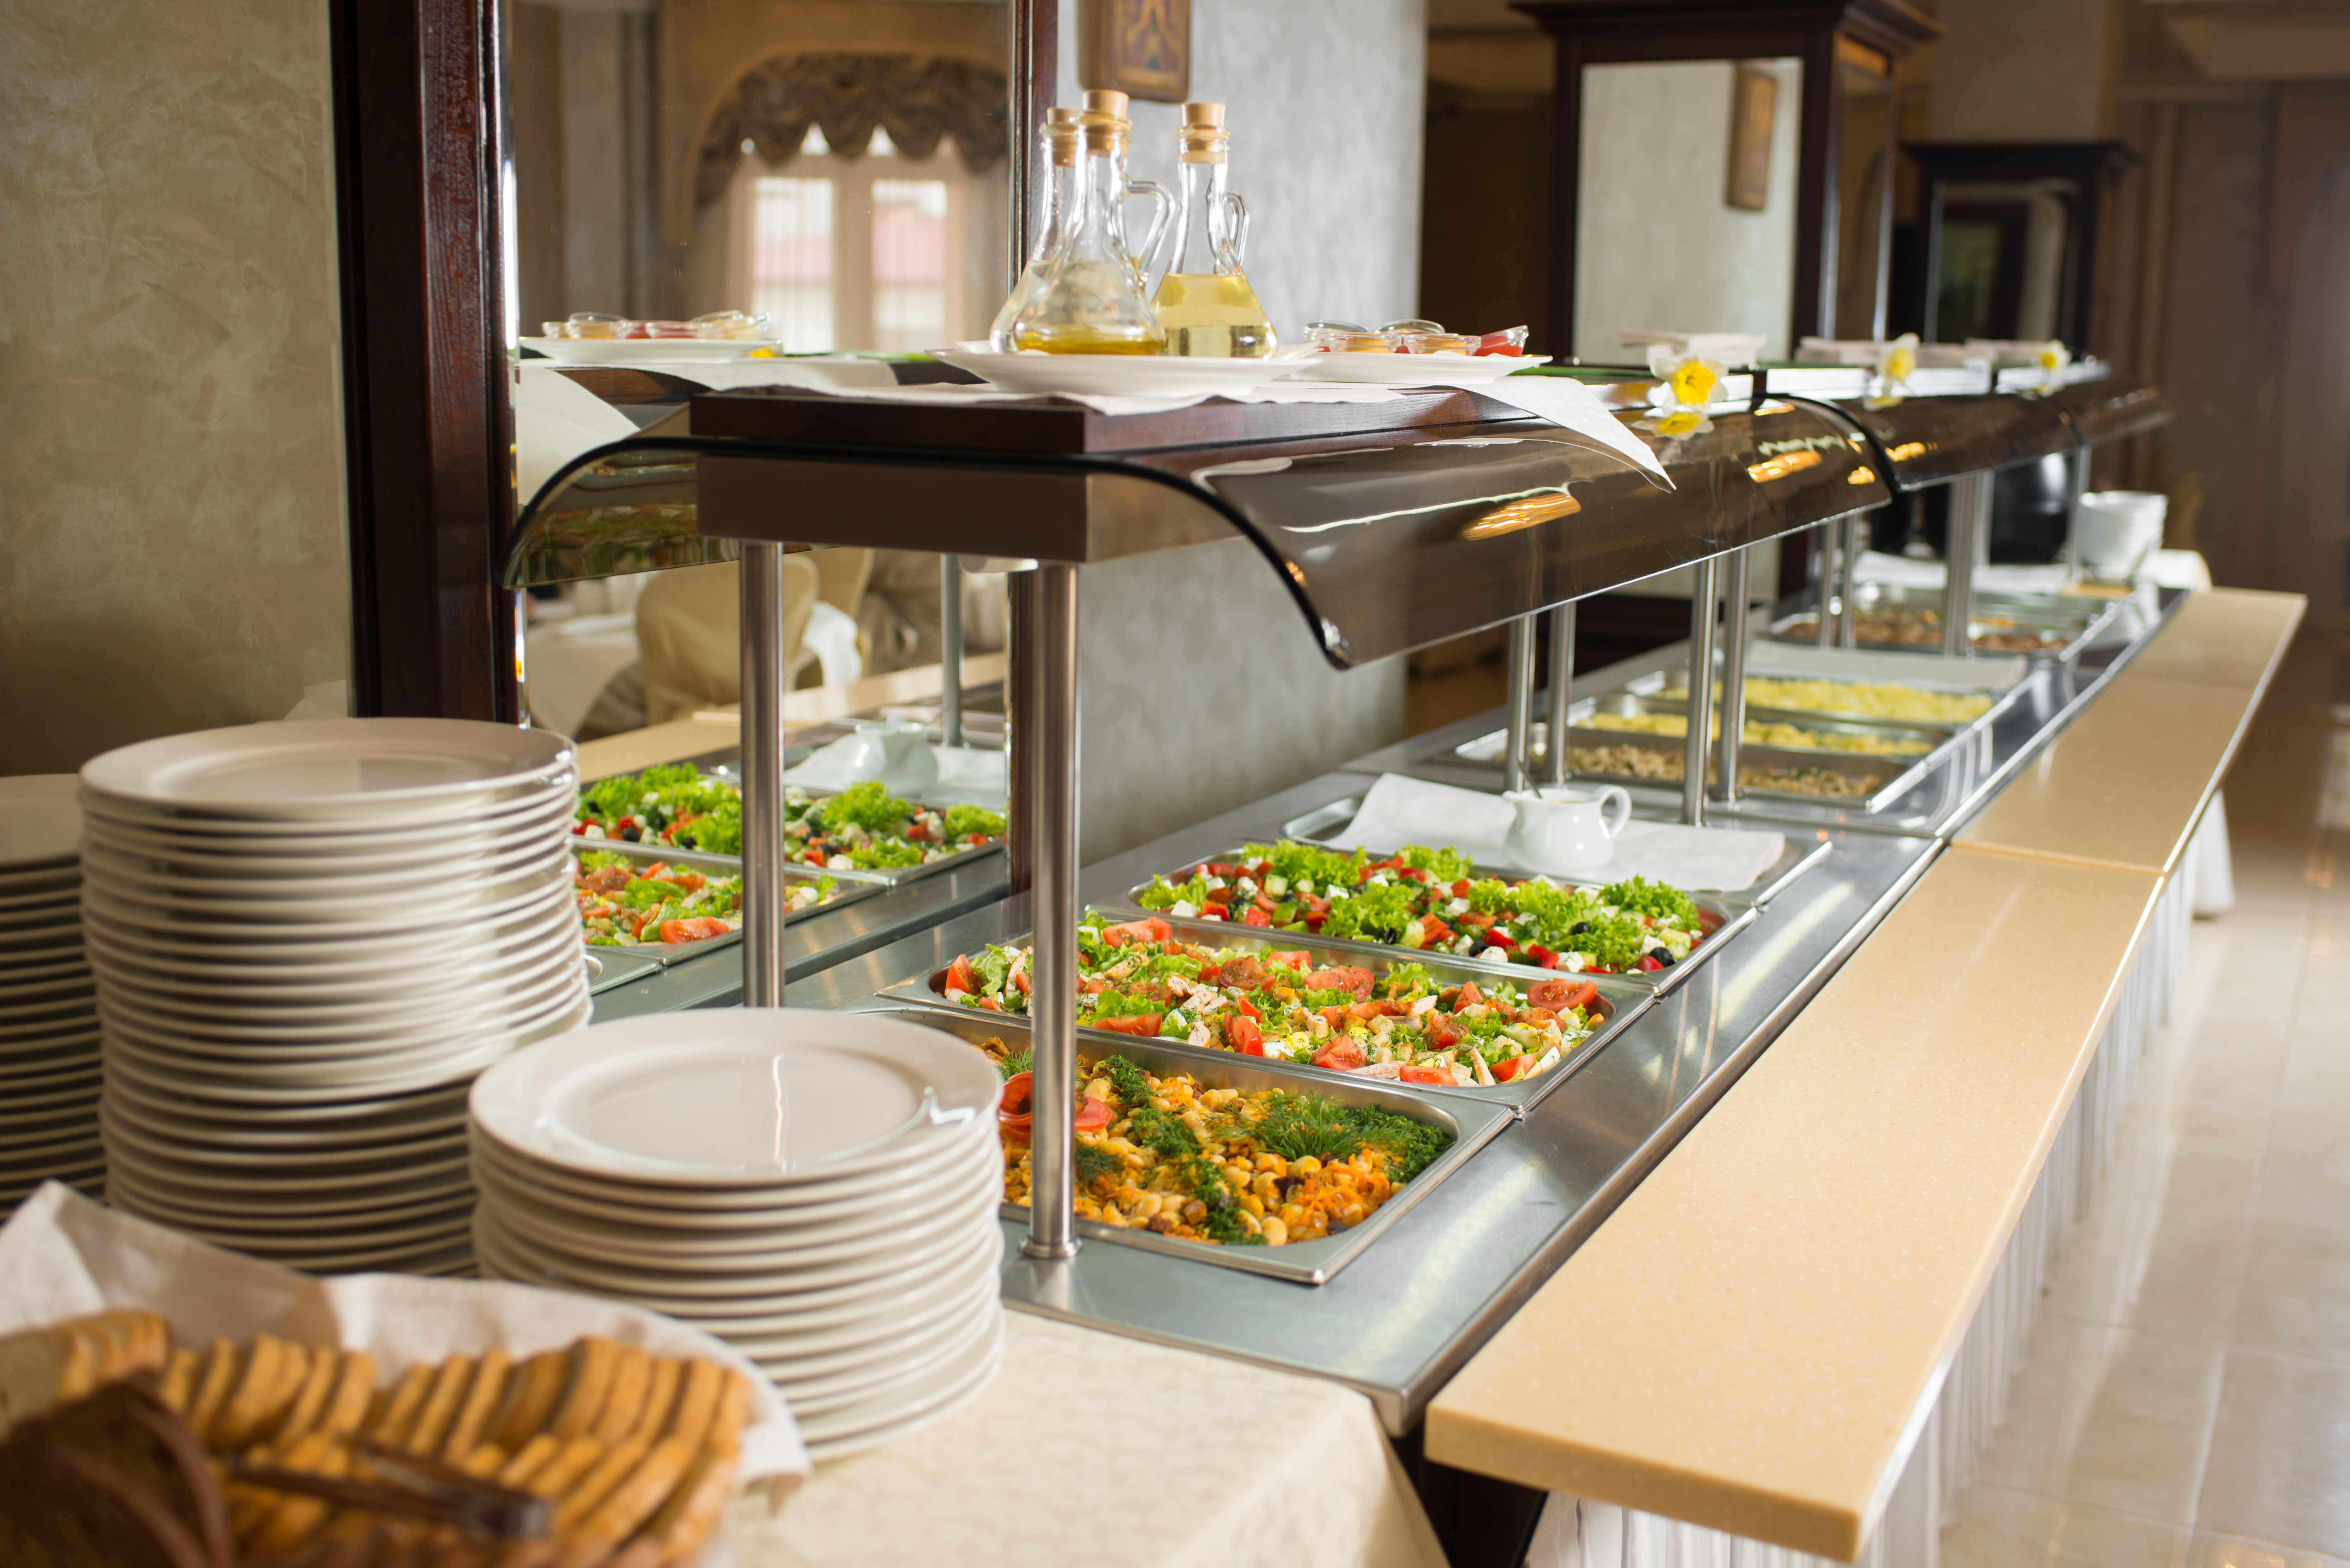

A reminder of SALIENT …
SALIENT is a large research project, made up of a team of more than 30 researchers across England. We are working together to find out how the food system can support people to have healthier and more sustainable diets.
The SALIENT team are making small changes in places like supermarkets, canteens and food banks. We are then researching if these changes help people buy and eat food that is more nutritious, and better for the planet.

Introducing our second Food Trial …
Workplace canteens: increasing the number of vegetarian options at lunchtime

How does eating vegetarian meals and meat alternatives help the planet?
It’s better for the planet!
You don't have to be vegetarian or vegan to help the planet.
Consciously eating less meat (less than 100g a day) can almost halve the amount of greenhouse gas emissions produced and land used to farm animals, compared to people who eat more than 100g a day (click here to learn more).
Rising concentrations of greenhouse gases is leading to global warming and climate change.
So eating vegetarian meals/meat alternatives is better for the planet.
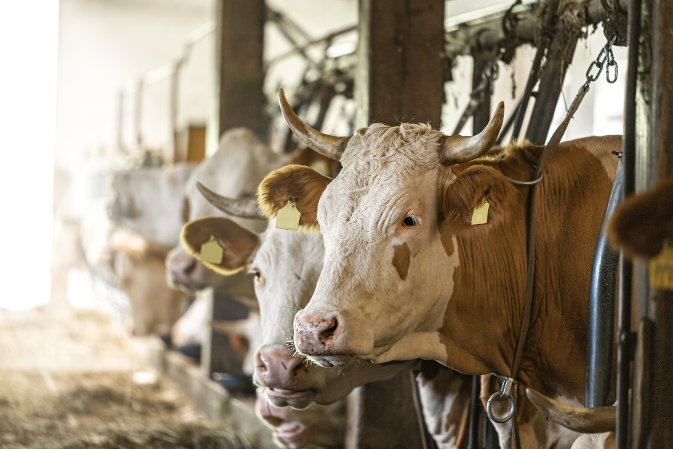

It’s also good for your health!
Eating more meals containing vegetables or fruits is known to reduce the risk of heart disease and certain types of cancer (click here to find out more). It also improves your immune system due to the variety of vitamins and nutrients they contain.
On the other hand, eating a lot of red and processed meat is linked to a number of cancers, including colorectal, pancreatic and prostate cancers, and heart disease (click here to find out more).
This means meals which have a lower meat content and a higher fruit and vegetable content are better for people’s health long term.

What did we do?
In this trial, we replaced one fish-based meal or meat-based lunch meal (e.g. beef chilli) with a vegetarian option (e.g. three bean chilli). The option of a meat-based meal was always available, so people could freely choose if they wanted a meat/fish or vegetarian meal.
We looked at whether increasing the number of vegetarian options on offer made a difference to the sales in workplace canteens.

Why are we focusing on workplace canteens?
In the UK, six in ten companies have canteens for their employees (click here to find out more). We thought workplace canteens might be a good place to start testing whether increasing the number of vegetarian meals available can change people’s food choices.
Our food choices often comes down to our habits that have built over time. Many people will choose the same meals due to habit and familiarity. One way we can change people's habits (in this case, to eat more vegetarian food) is by changing what is available when people are buying food at work.

When did this happen?
These changes were rolled out between September and November 2023.

Where did this take place?
We made these changes in six workplace canteens over seven weeks. All canteens were run by the same catering company.

What have we found?
We’ll have more results in a later issue, but early findings suggest that replacing one meat/fish based meal with a vegetarian meal meant the likelihood of buying a vegetarian meal went up by around 40%!

Where can I find out more about the study?
Read about our study in our protocol, by clicking on this link.
Did you know?
The UK’s first fully plant-based workplace canteen opened earlier this year in Stroud, Gloucestershire. Click here to find out more.


ABOUT SALIENT
Who SALIENT works with to test these food systems changes
The SALIENT Team work with two main groups.
We work with partners in the food system (e.g. retailers, caterers, food banks) to run our trials. The SALIENT team are independent of these food system partners – our trials are not funded by them and we do not work for them.
We also work with people who are active in their communities, who give us ideas and feedback on the SALIENT trials. They have helped us design this newsletter.

About this newsletter
This newsletter is for everyone interested in the work that is happening across SALIENT.
We welcome your views on it. Email us at salientcommunity@herts.ac.uk.
To subscribe to receive the email version of this newsletter, please email Claire Thompson at c.thompson25@herts.ac.uk.

Copyright information
All the images within this newsletter, unless otherwise indicated, have been licensed by Adobe Stock, under an Education License, with the University of Hertfordshire.

